Assignment 2

1. How can you initialize a repository in Git? Write Command.

**A new repo from an existing project**

Say you’ve got an existing project that you want to start tracking with git.

* Go into the directory containing the project.
* Type git init.
* Type git add to add all of the relevant files.
* You’ll probably want to create a .gitignore file right away, to indicate all of the files you don’t want to track. Use git add .gitignore, too.
* Type git commit.

**Connect it to github**

You’ve now got a local git repository. You can use git locally, like that, if you want. But if you want the thing to have a home on github, do the following.

* Go to [github](https://github.com/).
* Log in to your account.
* Click the [new repository](https://github.com/new) button in the top-right. You’ll have an option there to initialize the repository with a README file, but I don’t.
* Click the “Create repository” button.

Now, follow the second set of instructions, “Push an existing repository…”

$ git remote add origin git@github.com:username/new_repo

$ git push -u origin master

Actually, the first line of the instructions will say

$ git remote add origin https://github.com/username/new_repo

1. Create repository named - **Employee** . After that create branch named -  **Employee_Details.**

Repository Name= Employee – > Student

Employee_Details --> Student_Details

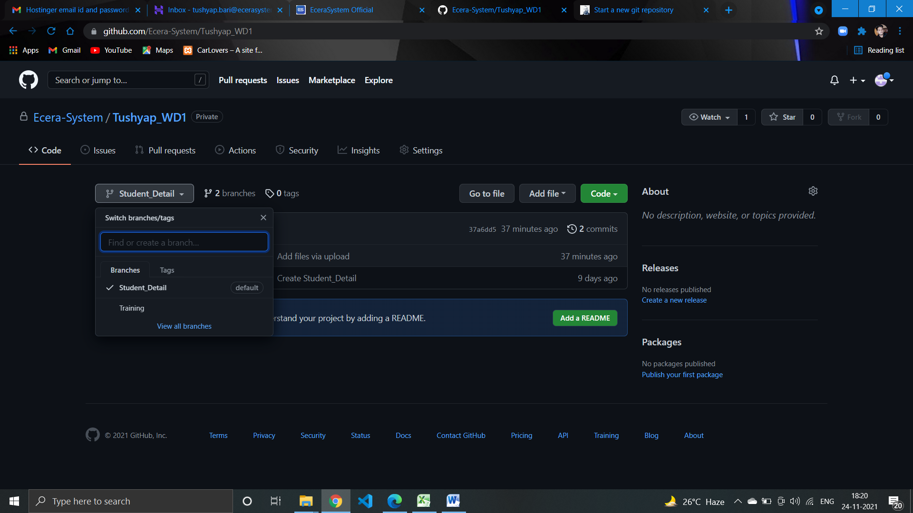

1. In  **Employee**  repository check the status and later commit new file or folder in it.

I have uploaded the File – Assignment Of Agile

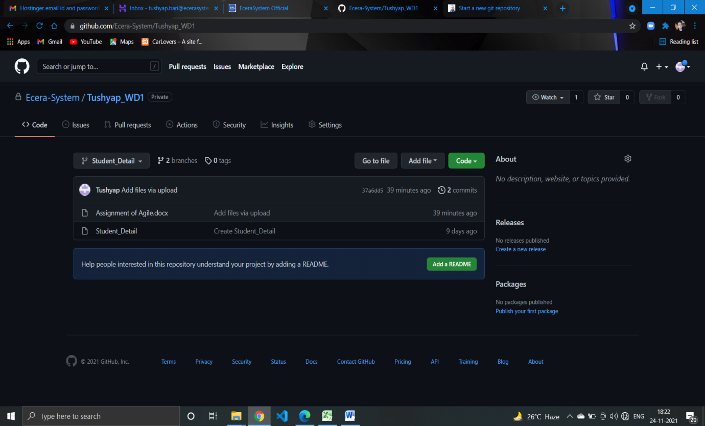

1. Merge two branch in **Employee** respository .

